Nikhil Kishor Patil

Amalner,India 9356883481

[nikhilpatil4074@gmail.com](mailto:nikhilpatil4074@gmail.com)

 linkedin.com/in/nikhil-patil-0a49762ba

 https://github.com/NikhilPatil2

Electronics and Telecommunication Engineer

 **PROFILE**

B.Tech graduate in Electronics and Telecommunication to seek an opportunity to utilize and improve my skills with an organization of repute for personal and organisational development.

# Participation

**GDSC** BootCamp

National Blood Donation camp

4 Days Basic electronics workshop

* Tree Plantation At Karvand

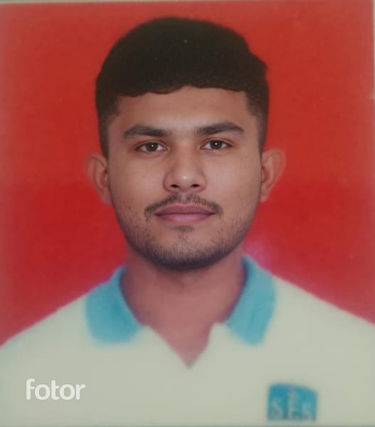

# SKILLS

**Technical skills : -** AutoCAD,

Computer Typing.

**Programming Skills : -** Basic Knowledge of C ,Java.

**Soft Skills : -** Problem Solving , Teamwork , Time Management , Public Relation , Critical Thinking.

# EDUCATION LANGUAGES

**R. C. Patel Institute Of Technology**

*B-tech in ENTC*

2023 – present | Shirpur, India

English Hindi Marathi

# HOBBIES

Gaming

Painting

Travelling

Clicking Photoes

 **CERTIFICATES**

Alimentary and Intermediate Examination

* Computer Typing
* National Cadet Corps (NCC)

Java programming by CodSoft. - September 2024